I am looking for help in obtaining specimens of potato psyllids (Psylloidea; Bactericera cockerelli) from the plant species Solanum xanti (also called S. umbelliferum) in northwestern California (either Humboldt, Trinity, or Del Norte counties would be okay). I have $1000 in grant funds to pay someone to locate and collect psyllid specimens (adults or immatures) from this host species. I do not need an extensive number of insects.

Potato psyllid specializes on solanaceous plants (potato, tomato, etc.). There are records from the 1930s documenting its association with Solanum xanti in the Bay Area, and I am trying to confirm that the same association occurs north of that region. A map of California plant records for Solanum xanti is provided in Calflora (https://www.calflora.org/app/taxon?crn=7666); a similar map is available for Solanum umbelliferum (https://www.calflora.org/app/taxon?crn=7664).

If this is of interest to you, please e-mail Dave Horton at the address provided below, and we can discuss things in more detail (including hints on collecting methods).
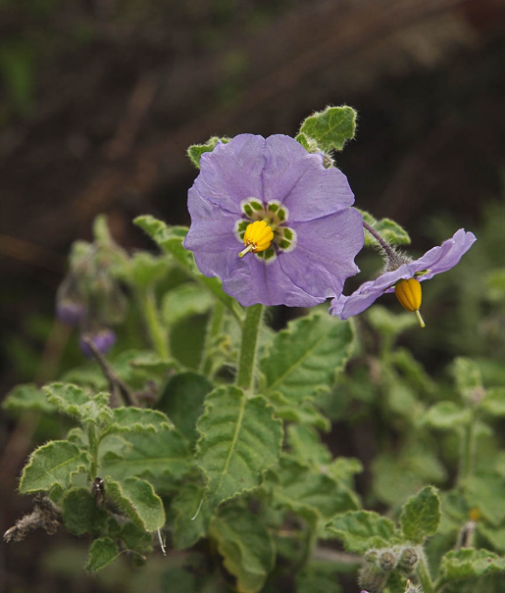
Photographs of all stages of potato psyllid: https://cisr.ucr.edu/invasive-species/potato-psyllid.

If interested, please contact:
David Horton
USDA-ARS
David.horton@usda.gov

