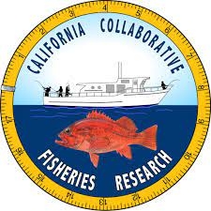
SUMMER JOB OPPORTUNITY: Collaborative Fisheries Research Technicians
The North Coast California Collaborative Fisheries Research Program is seeking part-time paid fisheries technicians on 6-pack sport-fishing vessels for monitoring nearshore rocky reef fish communities in Northern California Marine Protected Areas (MPAs).
Technicians gain valuable experience at sea in marine fisheries research. The project is based at Cal Poly Humboldt and will have 6 trips run roughly June – September 2023, out of Fort Bragg and Eureka harbors.
Duties:
- Participate in all aspects of hook-and-line sampling in survey sites, including hook & line fishing, fish identification, measurement, tagging, data recording, and equipment management.
- Assist in the processing of sacrificed fishes after trips.
- Be an enthusiastic ambassador of the project with collaborating researchers, captains, and volunteers of the larger fishing community.
Requirements:
- Experience in scientific collection of fisheries or wildlife data, confidence and care in handling fishing gear and live fish. Fishing experience preferred but not required.
- Experience on vessels in offshore environments; with the ability and motivation to work long days in challenging ocean conditions while maintaining a positive attitude.
- Reliability: Due to the unpredictable nature of North Coast weather, sampling trips are frequently rescheduled with less than 48 hours notice, and occasionally less than 24. The candidate must be responsive to telephone and email and be ready to depart early (often before 5am) on sampling days.
Benefits:
- $17/Hour
- Travel to and overnight accommodation in Fort Bragg will be arranged by project leaders. Mileage incurred by technicians may be reimbursed if necessary.
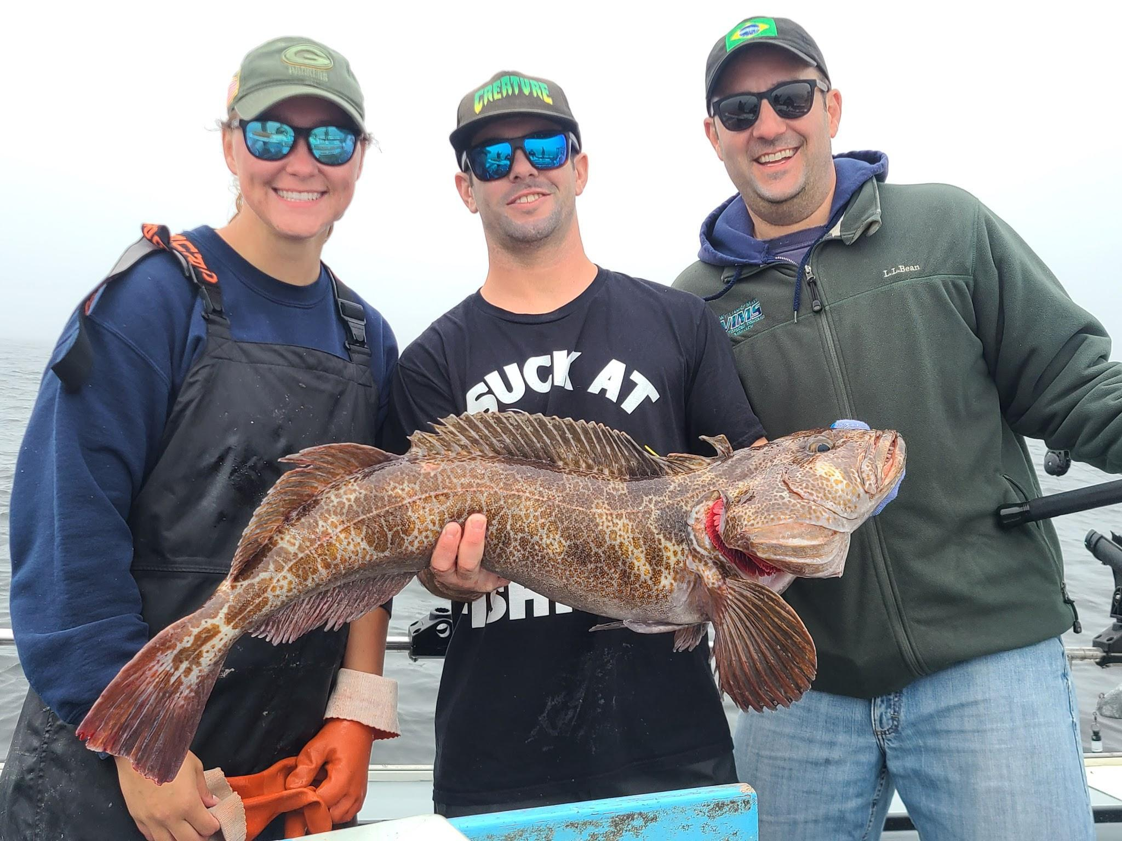
If interested – Please send a resume and one-page cover letter highlighting your relevant experience to Claire Stuart at claire.stuart@humboldt.edu with the subject line: “CCFRP Technician Position”.
Applications close April 30, 2023
Check us out on Facebook: @North Coast Collaborative Fisheries Research

